Task 21 - Install Prometheus and Grafana on a Linux EC2 machine, connect Prometheus to Grafana, and create a dashboard to view metrics.

The scripts to install,

1. Grafana:

#!/bin/bash

echo 'deb https://packages.grafana.com/oss/deb stable main' >> /etc/apt/sources.list

curl https://packages.grafana.com/gpg.key | sudo apt-key add -

sudo apt-get update

sudo apt-get -y install grafana

systemctl daemon-reload

systemctl start grafana-server

systemctl enable grafana-server.service

1. Prometheus:

#!/bin/bash

PROMETHEUS_VERSION="2.52.0"

wget https://github.com/prometheus/prometheus/releases/download/v${PROMETHEUS_VERSION}/prometheus-${PROMETHEUS_VERSION}.linux-amd64.tar.gz

tar -xzvf prometheus-${PROMETHEUS_VERSION}.linux-amd64.tar.gz

cd prometheus-${PROMETHEUS_VERSION}.linux-amd64/

# if you just want to start prometheus as root

#./prometheus --config.file=prometheus.yml

# create user

useradd --no-create-home --shell /bin/false prometheus

# create directories

mkdir -p /etc/prometheus

mkdir -p /var/lib/prometheus

# set ownership

chown prometheus:prometheus /etc/prometheus

chown prometheus:prometheus /var/lib/prometheus

# copy binaries

cp prometheus /usr/local/bin/

cp promtool /usr/local/bin/

chown prometheus:prometheus /usr/local/bin/prometheus

chown prometheus:prometheus /usr/local/bin/promtool

# copy config

cp -r consoles /etc/prometheus

cp -r console_libraries /etc/prometheus

cp prometheus.yml /etc/prometheus/prometheus.yml

chown -R prometheus:prometheus /etc/prometheus/consoles

chown -R prometheus:prometheus /etc/prometheus/console_libraries

# setup systemd

echo '[Unit]

Description=Prometheus

Wants=network-online.target

After=network-online.target

[Service]

User=prometheus

Group=prometheus

Type=simple

ExecStart=/usr/local/bin/prometheus \

--config.file /etc/prometheus/prometheus.yml \

--storage.tsdb.path /var/lib/prometheus/ \

--web.console.templates=/etc/prometheus/consoles \

--web.console.libraries=/etc/prometheus/console_libraries

[Install]

WantedBy=multi-user.target' > /etc/systemd/system/prometheus.service

systemctl daemon-reload

systemctl enable prometheus

systemctl start Prometheus

1. Nodexporter:

#!/bin/bash

NODE_EXPORTER_VERSION="1.8.1"

wget https://github.com/prometheus/node_exporter/releases/download/v${NODE_EXPORTER_VERSION}/node_exporter-${NODE_EXPORTER_VERSION}.linux-amd64.tar.gz

tar -xzvf node_exporter-${NODE_EXPORTER_VERSION}.linux-amd64.tar.gz

cd node_exporter-${NODE_EXPORTER_VERSION}.linux-amd64

cp node_exporter /usr/local/bin

# create user

useradd --no-create-home --shell /bin/false node_exporter

chown node_exporter:node_exporter /usr/local/bin/node_exporter

echo '[Unit]

Description=Node Exporter

Wants=network-online.target

After=network-online.target

[Service]

User=node_exporter

Group=node_exporter

Type=simple

ExecStart=/usr/local/bin/node_exporter

[Install]

WantedBy=multi-user.target' > /etc/systemd/system/node_exporter.service

# enable node_exporter in systemctl

systemctl daemon-reload

systemctl start node_exporter

systemctl enable node_exporter

echo "Setup complete.

Add the following lines to /etc/prometheus/prometheus.yml:

- job_name: 'node_exporter'

scrape_interval: 5s

static_configs:

- targets: ['localhost:9100']

"

After installing, go to the security group of the EC2 Instance and enable the below ports,

1. Port no. 9090 for Prometheus
2. Port no. 3000 for Grafana
3. Port no. 9100 for Node-exporter

After enabling the ports, now goto the location, /etc/Prometheus in the Prometheus installed EC2 instance and edit the Prometheus.yml file by adding the below configuration in the scrape configs section.

- job_name: "Node1"

# metrics_path defaults to '/metrics'

# scheme defaults to 'http'.

static_configs:

- targets: ["localhost:9100"]

Now the EC2 machine is added for the metrics and it can be viewed in the Prometheus target option.

Restart the Prometheus once,

$sudo service restart Prometheus

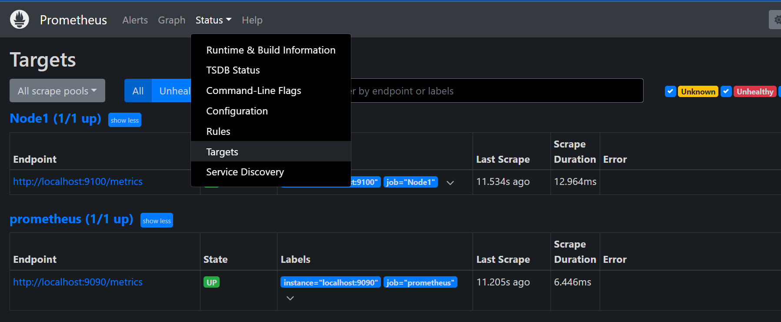

Now open the Grafana, goto the dashboard option,

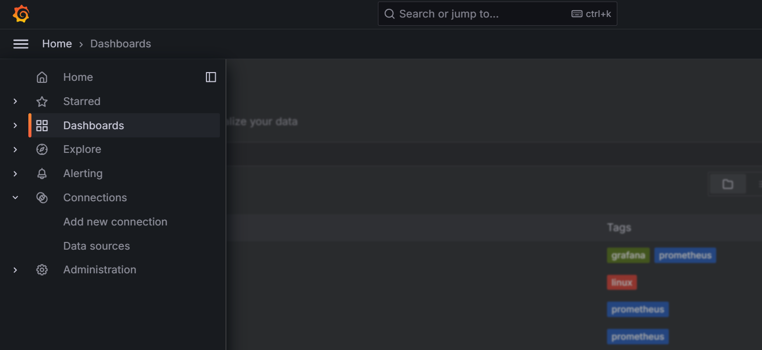

Click on the New 🡪 Import

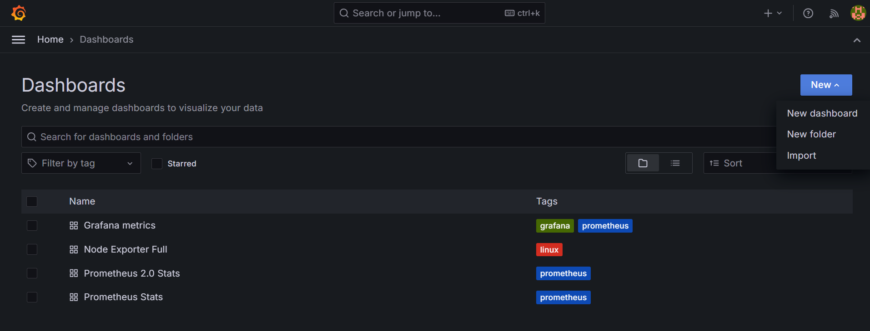

Enter the dashboard ID and select the Load option

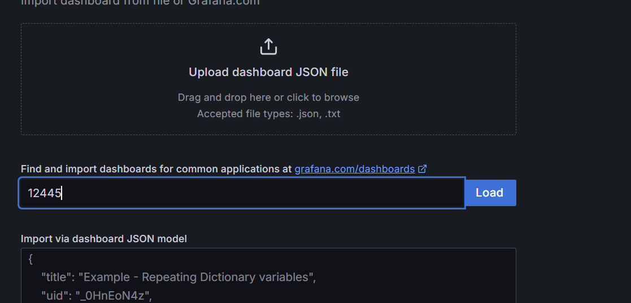

The Dashboard will be loading as below,

